WORKER SCHEDULE 2023 JOHN HELLIE TOURNAMENT
6/2/23 – 6/4/23
All parents are required to participate in this tournament to make it a success. Coaches, Concession Stands, Field Workers, Finance, On-Line support, Set Up, and Clean Up are all critical to our event.
There are countless people that work the entire weekend, and everyone’s help is needed. Please do not miss your shift! Just a reminder, to receive your deposit back this is one of the requirements.
We are all responsible for clean-up throughout the weekend. Everyone is asked to assist in set up and take down after the event. Set up starts at noon on Friday and take down will start during Championship games on Sunday.
If you are not able to work your scheduled shift, it is your responsibility to find someone to trade with or to work your shift. Workers must be 16 years of age or older. A parent contact list is provided at the end of this document.
It is likely that your shift may occur during your child’s game, it is very difficult to avoid that from happening. Attempt to trade a shift with another parent. You can also talk to the workers scheduled before or after your shift to see if they can stay a little longer.
If your name was missed, stop by the Pioneer Stand on Saturday and we will find you a spot to help.
**Please train incoming staff at the end of your schedule prior to departing**

Tournament Directors
Dylan Pittman
Josh Athman

Concession Chairs: Mickey Young, Beep Jacobson, Becky Weyer
On Line Support: Carrie Virnig (Pierz), Amber Gruber (Genola), Dawn Henderson (Pierz/Genola)
Coach Registration/Check In:
Fri. 4:30-7:30 Alison Posch & Kristin Andres
Sat. 7:30-10:00 Amanda Marshik
Finance: Missy & Ryan Solinger
Scheduling: Alison Posch & Kristin Andres

In case of RAIN: Watch the updates online and from your coach for updated start times of games. For those that have a shift that is completely canceled, we ask that you return at the end of the day to help cover later shifts. Example if your schedule starts at 8:30 am and games do not start until 11:00, please come to concessions at the end of the day to help out. If you are scheduled for FIELD WORK, please arrive at your scheduled time. We will need help covering and/or drying fields.

Pioneer Concession Stand

SATURDAY 6/3
Time | Workers |  | Grillers  10:30-1:30 – Chad Smieja & Russell Woitalla  1:30-4:00 – Andrew Smude & Justin Athman  4:00 through clean up – Travis Talberg & Matt Kessler  Cart Runners  10:30-1:00  Erin Schlieman  Kim Radunz  1:30-4:00  Krista Smude  Kari Maus
8:30-11:00 | Shirley Kimman  Ruth Stuckmayer
9:00-11:30 | Kaitlyn Smith
9:30-12:00 | Stacie Gross
11:00-1:30 | Joe Meyer  Keith Janson
11:30-2:00 | Eric Valencia
12:00-2:30 | Josh Girtz  Patrick Stangl
1:30-4:00 | RaeAnn Waytashek  Jenny Sadlovsky
2:00-4:30 | Julie Athman
2:30-5:00 | Beth Andria
4:00-6:30 | Danny Kimman  Russ Marshik
4:30-7:00 | Jeremy Yanta
5:00-through cleanup | Jenny Thielen

SUNDAY 6/4
Time | Workers |  | Grillers  10:30-12:30 – Mike Foust, Steve Maus  12:30-2:30 – Buck Radunz, Randy Waytashek  2:30-End – Gary Meyer  Cart Runners  10:30-1:00  Mary Caughey  Jodi Saehr  1:30-4:00  Shelby Janson  Cassey Talberg
8:30-11:00 | Amanda Smieja  Brenda Prokott
9:00-11:30 | Kari Kimman
9:30-12:00 | Becky Dehler
11:00-1:30 | Kari Theis  Kelly Stangl
11:30-2:00 | Greg Pohlkamp
12:00-2:30 | Amber Woitalla
1:30-4:00 | Hailey Bednar  Matt Hoheisel
2:00-4:30 | Cindy Marshik
2:30-5:00 | Katie Poser
3:30-through cleaning | Jeremiah Trutwin  Desiree Bednar  Brad Bednar  Nicole Brau

Legion Stand (AKA Hellie Field)

FRIDAY 6/2
Time | Workers |  | Grillers  5:30-7:30 Luke Solinger  7:30-End Kelly Jansen  Cart Runners  Mickey Young & Beep Jacobsen
5:30-7:30 | Stacy Foust, Shelley Solinger, Joan Kotila
7:30-End | Keith Posch & Mary Jansen

SATURDAY 6/3
Time | Workers |  | Grillers  10:30-1:00 – Tony Scheel, Chris Young  1:00-3:30 – Mark Kimman, Rick Schlieman  3:30-6:00 – Jim Gross, Jason Sadlovsky  6:00 – through clean up – Rick Gall
8:30-11:00 | Jill Hardy  Cari Woitalla
9:00-11:30 | Brenda Becker
11:00-1:30 | Rachel Maurer  Angela Athman
11:30-2:00 | Ashley Toops
1:30-4:00 | Becky Barclay  Julie Lochner
2:00-4:30 | Miranda Hoheisel
4:00-6:30 | Jill Kessler  Heather Kimman
4:30-7:00 | Beth Maus  Katie Hoheisel
6:30-9:00 | Michelle Litke
7:00-9:00 | Jennie Tax
8:00-through cleanup | Rachel Young & Tina Boser

SUNDAY 6/4
Time | Workers |  | Grillers  10:30-1:00 – Kevin Marshik, Drew Gruber  1:00-3:30 – Andy Thielen  3:30-End – TJ Watercott
8:30-11:00 | Christine Bakke  Cindy Pohlkamp
9:00-11:30 | Steve Andres
11:00-1:30 | Kelli Diedrich  Josie Kimman
11:30-2:00 | Kathie Winscher
1:30-4:00 | Amanda Hennessy  Bridget Trutwin
2:00-4:30 | Toni Meyer
4:00-through clean up | Kristen Williams  Tara Watercott, Amanda Woitalla

FIELDS
Drag the fields and chalk after EVERY game. The group assigned is responsible to train the next group if they are not familiar with the process or the equipment.
**It is critical that we keep up with the fields and have parents pitch in whenever possible**

Genola Fields
Friday 6/2
7:30-End | Shawn, Kirby & Tyler Fischer

Saturday 6/3
9:00-12:00 | Marvin Stuckmayer, Joey Stuckmayer, Weston Woitalla
12:00-3:00 | George Dehler, Jason Bakke, Derik Bakke, Kalvin Girtz
3:00-6:00 | Jeff Jacobson, Hunter Jacobson, Kaden Krushek, Tom Krushek,
6:00-End | Josh Stangl, William Stangl, Nathan Solinger

Sunday 6/4
10:00-1:00 | Kyle Winscher, Wes Winscher, Jack Prokott, Brian Prokott
1:00-4:00 | Darren Weyer, Deven Weyer, Mitch Becker
4:00-End | Shane Barclay, Max Barclay, Ben Barclay

Pioneer Fields
Friday 6/2
7:30-End | Cory Williams, Chad Poser, Nick Woitalla

Saturday 6/3
9:30-12:30 | Jeff Young, Reese Young, Nick Kotila
12:30-3:30 | Brandon Lochner, Paul Hennessy, Liam Hennessy
3:30-6:30 | Brayden Haberman, Greg Tax, Mike Haberman

Sunday 6/4
9:30-12:30 | Rick Virnig, Eric Hardy, Jackson Daiker
12:30-3:30 | Joe Thielen, Jackson Thielen, Logan Brau
3:30-End | Chad Tomala, Eliott Tomla, Carter Young, Chad Hoheisel

10 U
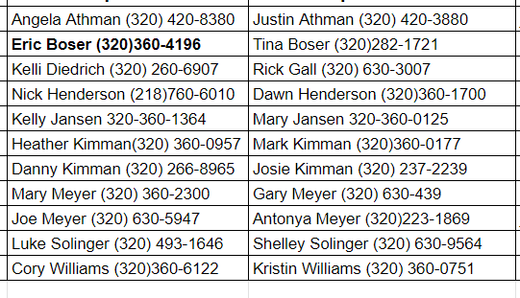

11 U
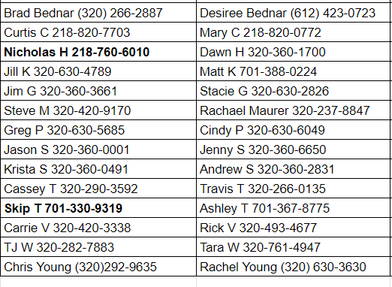

12 U
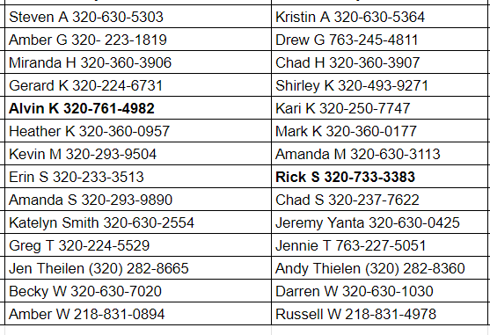

13 U
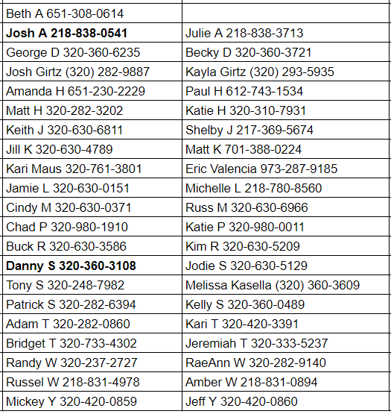

14 U
